Assignment 1

Jacob Taylor Cassady

Deep Learning

January 23, 2020

# Show that the tanh function is a re-scaled sigmoid function with both horizontal and vertical stretching, as well as vertical translation: tanh(𝑣) = 2𝑠𝑖𝑔𝑚𝑜𝑖𝑑(2𝑣) – 1

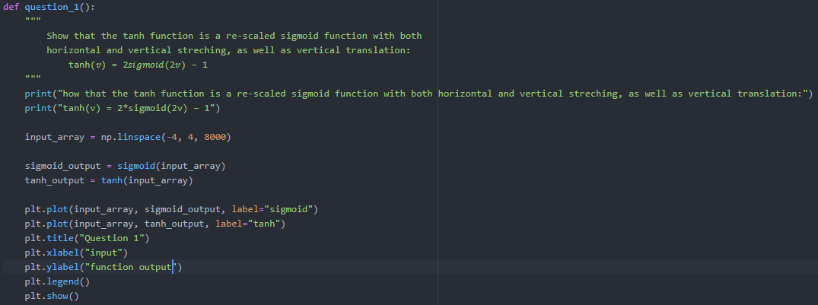

# Show the following properties of the sigmoid and tanh activation functions:

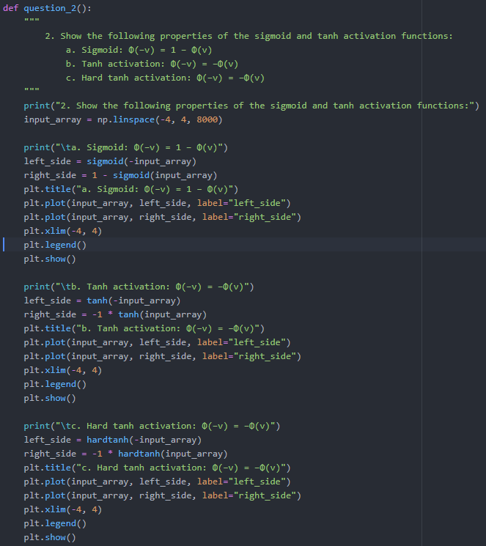

## Sigmoid: Φ(−v) = 1 − Φ(v)

Note: Both function outputs are directly on top of each other.

## Tanh activation: Φ(−v) = −Φ(v)

Note: Both function outputs are directly on top of each other.

## Hard tanh activation: Φ(−v) = −Φ(v)

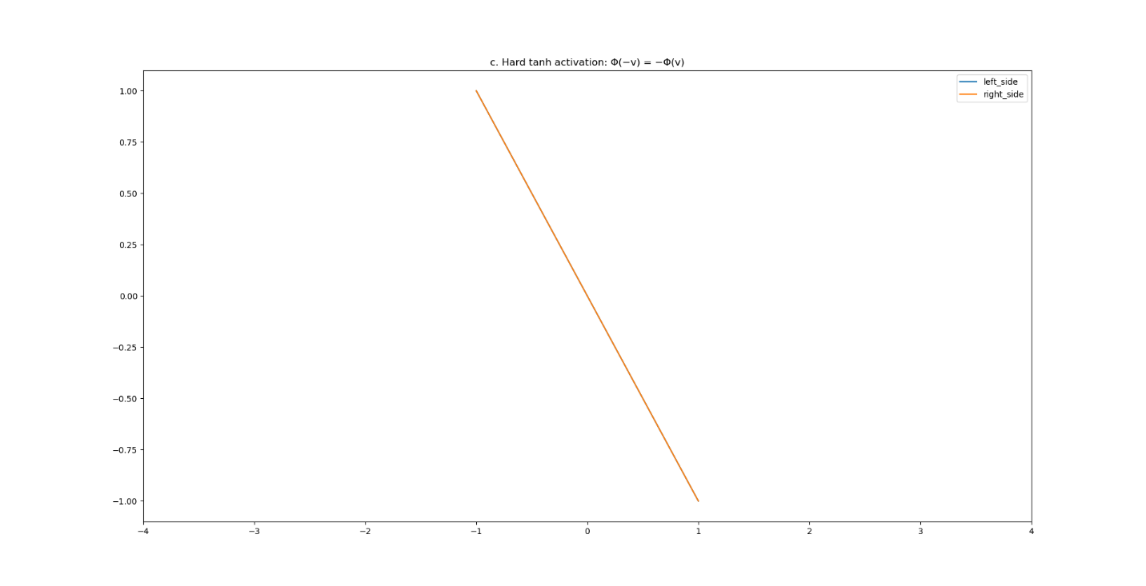

Note: Both function outputs are directly on top of each other.

# Consider the neural network:

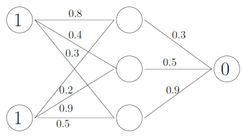

# All the activation functions from the neurons in the hidden layer are sigmoids and the error is calculated by using squared error function:

## Describe all the essential parts from the neural network.

There are three neurons in the hidden layer and one output neuron. The initial weights for the neurons are given in the lines connected to the left of the neuron and the bias is to the right of the neuron. The input features are {1, 1}. The target is {0}.

## Given the input {1,1} compute the predicted output of the network step by step and calculate the error if the target output is 0.

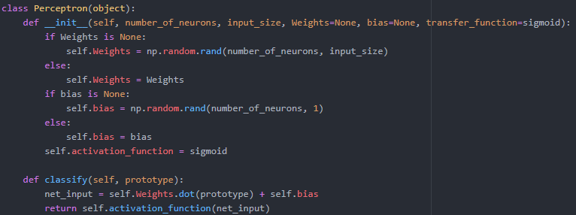

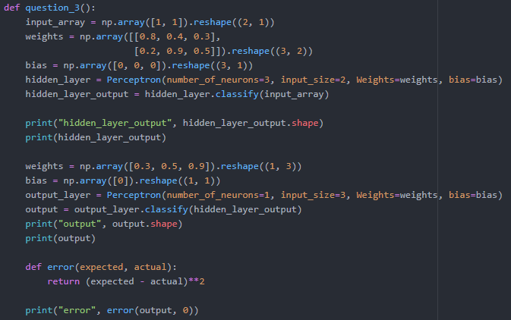

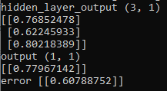

## Compute step by step 2 training epochs using Back-Propagation algorithm.

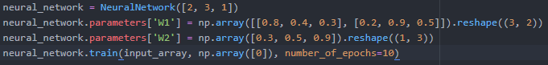

# Program your own MLP in Python for a basic neural network with one or to hidden layers and binary output (select the proper activation function)

## Generate a random data set for binary classification where each class correspond to the 2D region depicted in the figure. The random data should have normal distribution with variance 𝜎2=0.08. Use 200 points (100 in each region) to train your neural network and report the results in terms of the loss function and the training epochs.